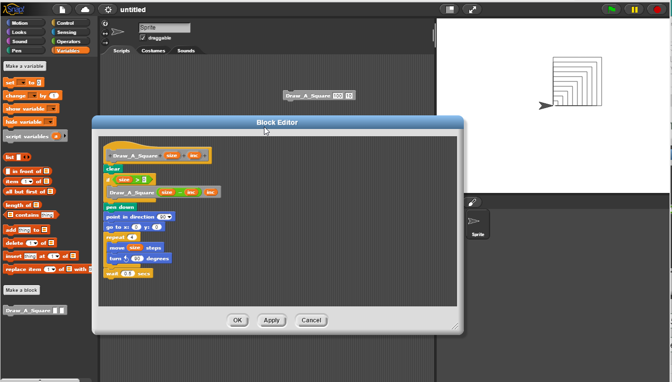

Call Sequence: (Draw_A_Square(100,10)) 🡪 (Draw_A_Square(90,10)) 🡪(Draw_A_Square(80,10)) 🡪 (Draw_A_Square(70,10)) 🡪 (Draw_A_Square(60,10)) 🡪 (Draw_A_Square(50,10)) 🡪 (Draw_A_Square(40,10)) 🡪 (Draw_A_Square(30,10)) 🡪 (Draw_A_Square(20,10)) 🡪 (Draw_A_Square(10,10)) 🡪 (Draw_A_Square(0,10)

Drawing Sequence: 0, 10, 20, 30, 40, 50, 60, 70, 80, 90, 100